The Calibration
Purpose of the calibration: To establish a common understanding between the universal use of fingers as counting instrument and associate them to the meaning of numbers (numerals) in the absence of a common language through a series of activity.
The following graphic illustrates this goal in a snapshot.
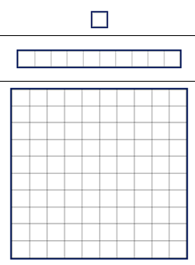

… 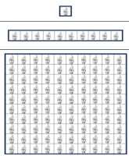 0,1,2,3,…

Note: While engaging in the calibration activity, students may also exhibit grade-level numeracy skills. Although assessing grade level numeracy skills is not the main intent of the calibration activity and establishing one-to-one correspondence is, the grade level standards that embed these numeracy skills are identified as supplementary goal in this grade four exemplar.
Before beginning: study the Calibration Key (the goal of the activity) on page 2 in this handout; become familiar with the Numeracy Skills Progression Chart (particularly the estimated grade level of the student) on page 11in this handout; the Finger Cards (pages 12-13) and Base Ten (pages 14—15) manipulatives you will be using.

Return to page 1
Calibration Key
The table below represents the relationship between the two Card sets
Relationship Between Card Sets
 | Base Ten | Finger
0  “zero” | *No graphic or visual representation for “zero” | *Point or gesture to empty Placement Mat
1
“ones”
10  “tens” |  | 
100  “hundreds” | 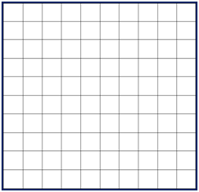 | 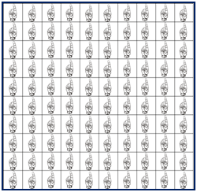
*The graphic representation of a zero in Base 10 and Finger Card does not exist and is represented as an empty cell.

Part A: Connecting “The Real Finger” with “Finger Card”
This activity is an interactive session wherein the proctor uses his or her fingers to show the relationship between the real fingers and the Finger Cards.
Moves in this activity would include the proctor holding one finger up in the air and pointing explicitly to the “ones” finger Card; holding 10 fingers in the air and then tapping on the ten finger Cards using one finger for every cell in the ten finger Card. The proctor may also have the student do the same.

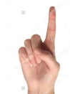 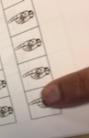 (counting) 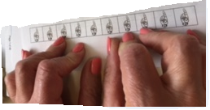

Part B: Matching Card “I Do” Activity
The following example illustrates the “I Do” Matching Card Activity. Please review the exemplar before doing the activity with the student. Add on similar items to the assessment as deemed necessary. Proctor and student sit across the table. Proctor uses both decks of Cards to establish the relationship between Base Ten Finger and Finger Cards.

Column One (Proctor “I Do”) | Column Two (Proctor “I Do”) | Proctor Moves Description
 |  | Move 1: Proctor selects a “ones” Finger Card and places it in Column One  Move 2: Proctor selects a “ones” Base Ten Card and places it in Column Two  Note: Proctor may select other manipulatives (Ex. Unifix cubes, Base Ten blocks)
Move 1: Proctor selects “tens” Finger Card and places it in Column One

Move 2: The proctor pulls out a “tens” Base Ten Card and places it in Column Two
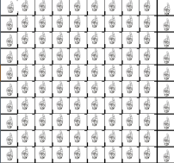 |  | Move 1: Proctor pulls up a “hundreds” Finger Card and places in Column One  Move 2: The proctor pulls out a “hundreds” Base Ten Card and places in Column Two
No picture  (Gesture by hand nothing, empty space) | No picture  (Gesture by hand nothing , empty space) | Move 1: Proctor gestures “nothing “and points to Column One, indicating “zero”  Move 2: Proctor gestures “nothing” and points to Column Two, indicating “zero”

Placement Mat for Part B Matching Cards “I Do” Activity

Column Two (Proctor “I Do”) | Column One (Proctor “I Do”)

Part C: Matching Card “I Do - You Do” Activity

The following example illustrates the “I Do - You Do” Matching Card Activity. Please review the exemplar before doing the activity with the student. Add on similar items to the assessment as deemed necessary.
Proctor and student sit across the table. Proctor uses the Finger Cards and student uses the Base Ten Cards.
Column One (Proctor “I Do”) | Column Two: (Student “You Do”)  Possible student responses (not an exhaustive list) | Proctor Moves Description | Secondary Goals (skills embedded in grade le grade level standards ) | Notes/Observation
 | A.  B.  C. | Move one  Proctor: Places a “tens” Finger Card in Column One.  If student response is A, then goal of question has been achieved  If student response is B, then proctor prompts with, “Show another way” until student demonstrates A  If student response is C, then proctor prompts with, “Show another way” until student demonstrates A  Note: All these responses are correct and show that the student possesses the underlying numeracy skills embedded in the grade four content standards. Assessment of these skills are called out in the Secondary goals Column) | 4OA(Generate and analyze patterns, gain familiarity with factors and multiples; use the four operations with whole numbers to solve problems);  4.MD (Solve problems involving measurement and conversion from larger to smaller unit) | Student placed10 ones but grouped by twos… demonstrates underlying grade level numeracy skills

Placement Mat for Part C: Matching Card “I Do - You Do” Activity

Column Two (Student “You Do”) | Column One (Proctor “I Do”)

Part D: Mixed Matching Card “I Do & You Do” Activity
The following example illustrates the Mixed Matched “I Do - You Do” Activity. Please review the exemplar before doing the activity with the student. Add on similar items to the assessment as deemed necessary.
Proctor places both sets of Cards at the center of the table. In this activity the proctor draws from both the Base Ten and Finger Cards and mixes them for the “I Do” part. The student is allowed to respond using the Base Ten Cards only.

Column One (Proctor “I Do”) | Column Two: (Student “You Do”) | Proctor Moves Description | “Secondary” goals(numeracy skills embedded in grade level standards) | Notes/Observation
 | A.  B.  C. | Move one:  Proctor: Places a 100 flat from Base Ten Cards and one “tens” Finger Card in Column One.  If student response is A, then goal of question has been achieved  If student response is B, then proctor prompts with, “Show another way” until student demonstrates A  If student response is C, then proctor prompts with, “Show another way” until student demonstrates A  Note: All these responses are correct and show that the student possesses the underlying numeracy skills embedded in the grade four content standards. Assessment of these skills are called out in the Secondary goals Column) | 4OA(Generate and analyze patterns, gain familiarity with factors and multiples; use the four operations with whole numbers to solve problems)  4.MD (Solve problems involving measurement and conversion from larger to smaller unit) – depends on student response | Student placed 11 Base Ten …demonstrating grade level embedded numeracy skills (factors and multiples) …  Student shows numeracy skills that may be below grade level …

Placement Mat for Part D: Mixed Matching Card “I Do & You Do” Activity

Column Two (Student “You Do”) | Column One (Proctor “I Do”)

Return to page 1
Numeracy Skills Progression Chart

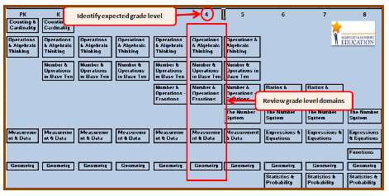

Finger Cards Black line Master

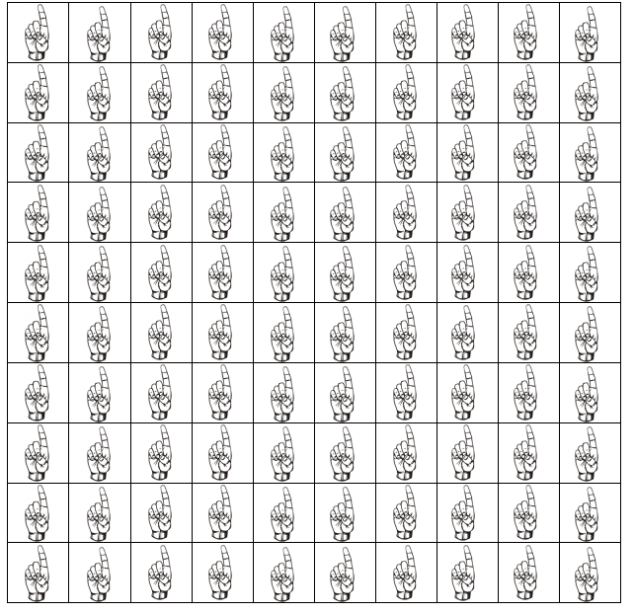
Return to page 1
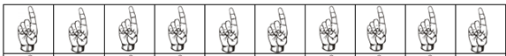

Base Ten Black line Master
Return to page 1
