Links & Ways to Find Things Shared
(Page #3)
Other Activities Shared:
(*Some images are from my classroom and others from Google Images. Directions and more information can be found on Pinterest)

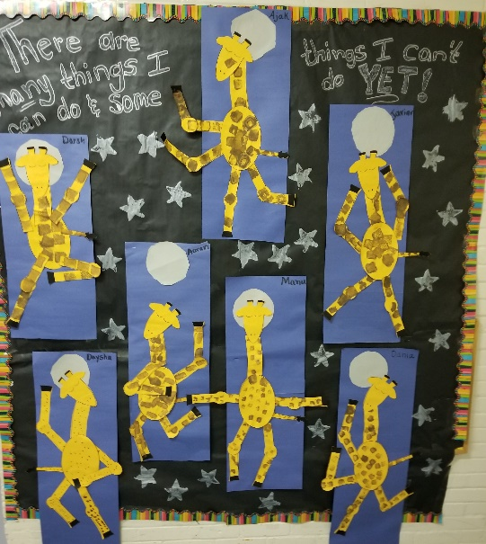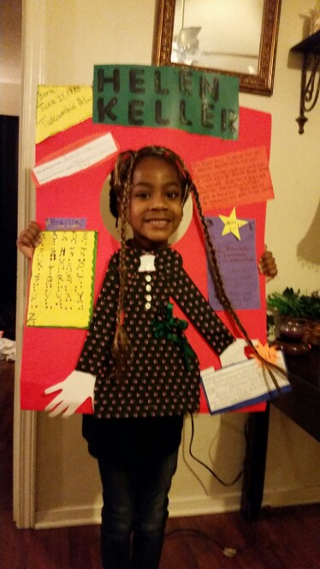
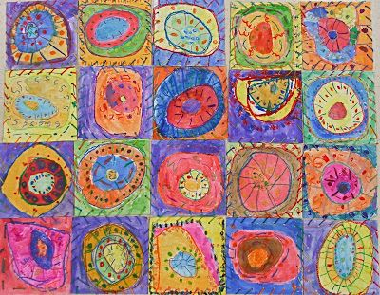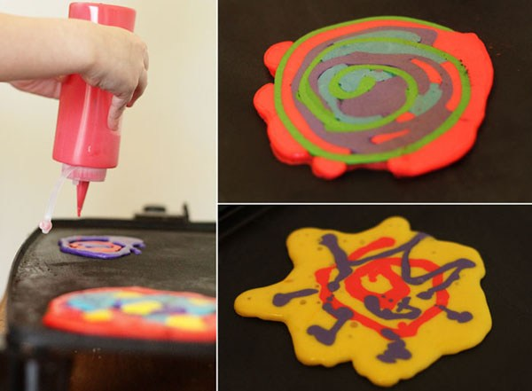

Molly Curren
E.S.L. Teacher
North Attleboro Public Schools
Work: (508) 643-2148 Cell: (508) 212-7191
Email: mcurren@naschools.net
mcurren275@comcast.net

