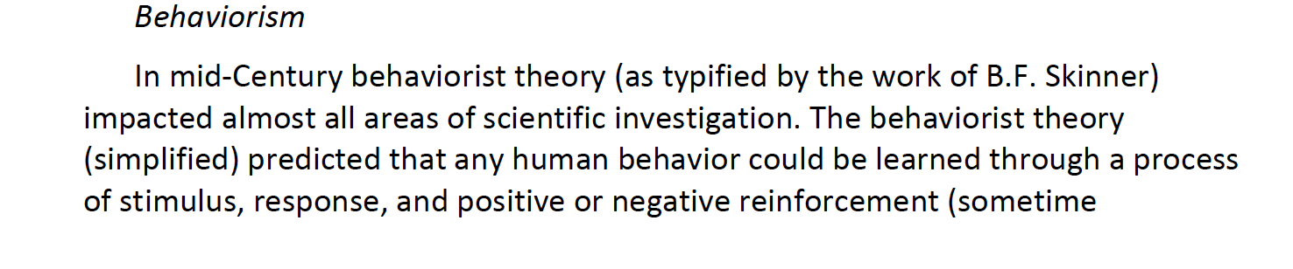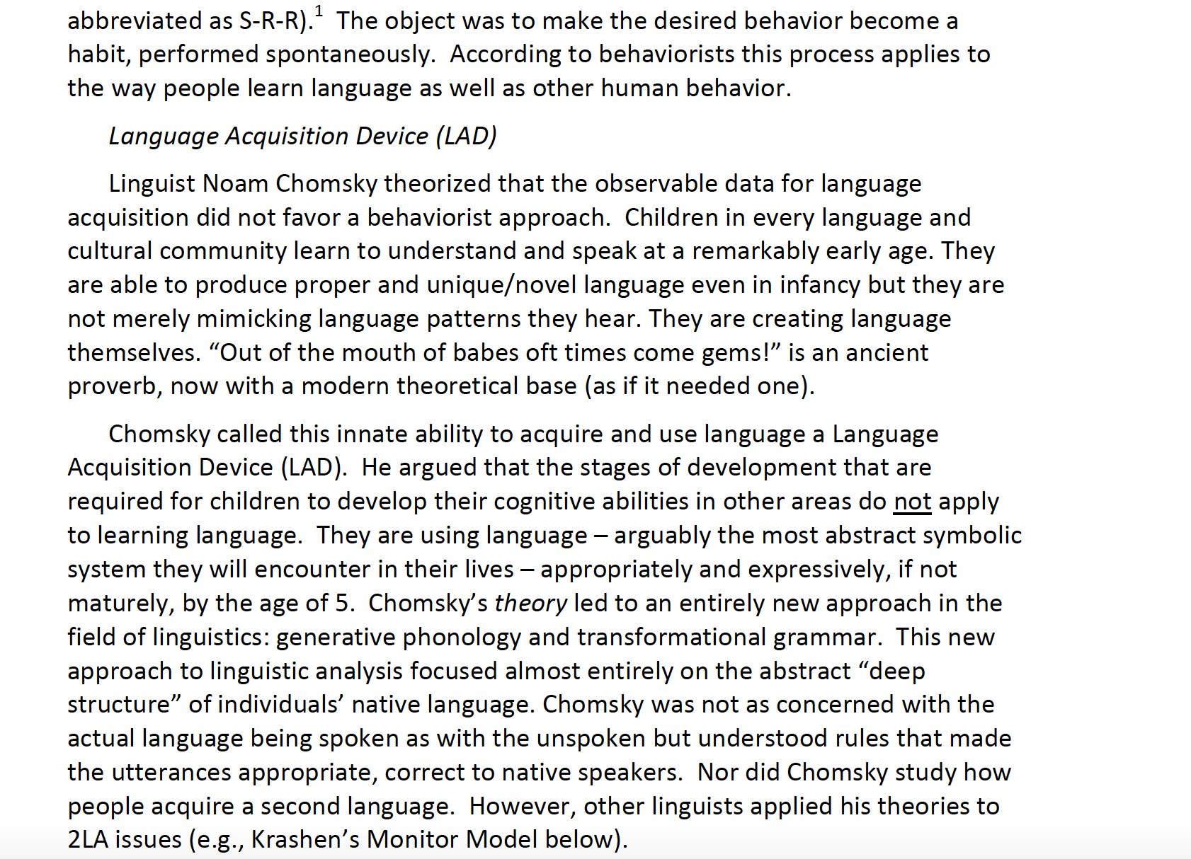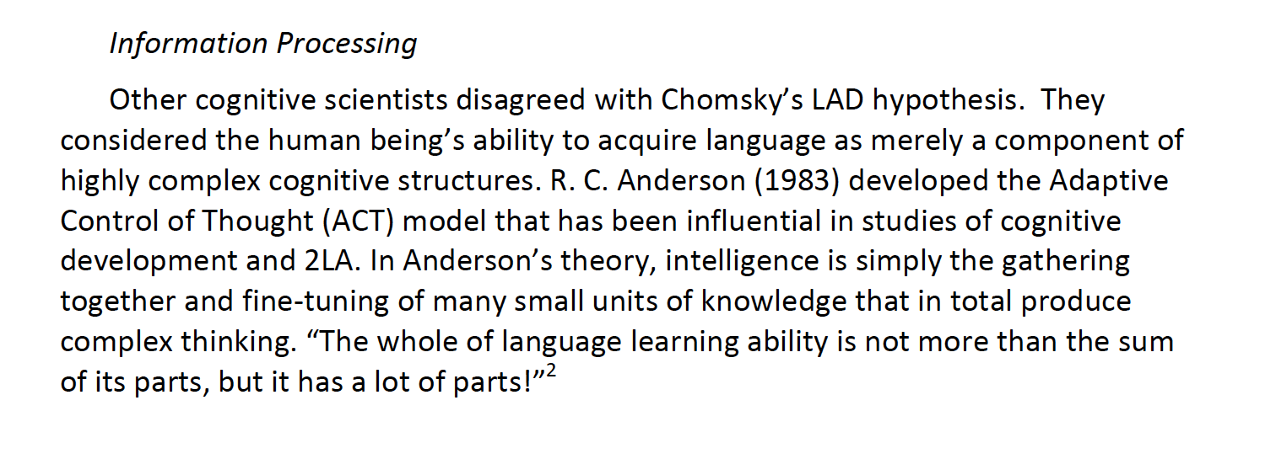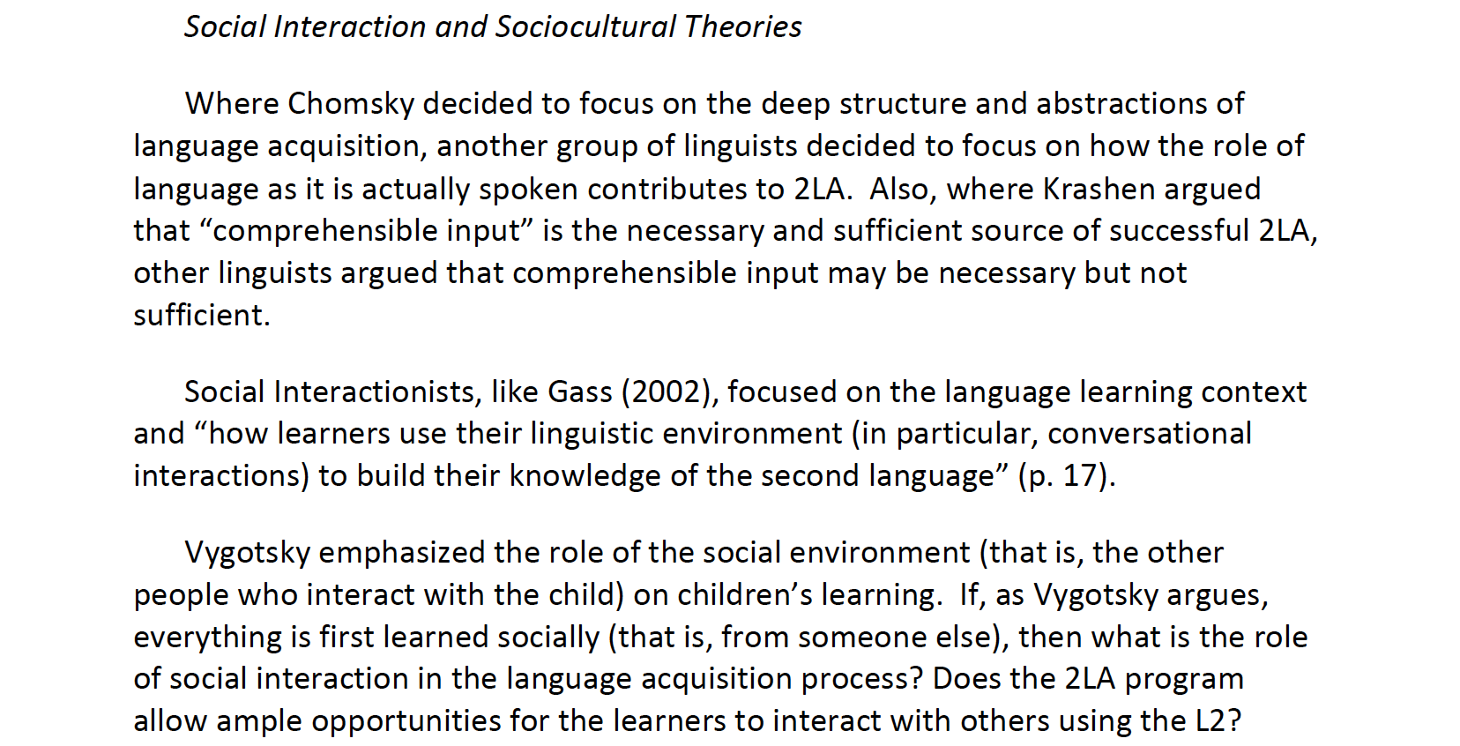
Reference

Malone, D. (2012). Theories and research of second language acquisition. Reading for day 2, Topic SLA Theories.
The whole text is a direct quotation from this reference.

