CONTENT RUBRIC FOR FOSS INSECT UNIT - Student Version
Content Area | 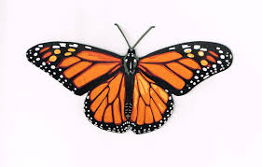butterfly | 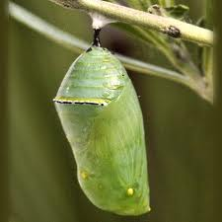 pupa | 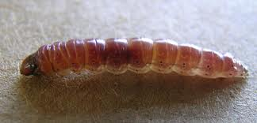 larva | 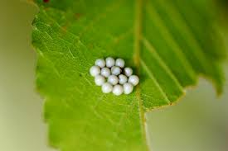 egg
Vocabulary  Associated with  Insects | I can match all 20 words from the first column and 15 words from the second column to the correct picture. | I can match all 20 vocabulary words to the correct picture. | I can match 10 – 19 vocabulary words to the correct picture. | I can match up to 9 vocabulary words to the correct picture.
Body Parts of  Insects | I can point to and name all 7 body parts on a variety of insects: head, thorax, abdomen, legs, eyes, wings, and antennae. | I can point to and name the 3 basic body parts on a variety of insects: head, thorax, and abdomen. I can also point to and name 2 or 3 of the other body parts: wings, legs, eyes, or antennae. | I can point to and name 2 of the 3 basic body parts: head, thorax, and abdomen. I can also identify or label 1 or 2 of the other body parts: wings, legs, eyes, or antennae. | I get mixed up sometimes when I say the name of the three body parts. It is easier for me to point to the correct picture when I hear the right word.
Life Cycle of  Insects | I can put the pictures of the 4 stages of the life cycle in the right order, name each stage, and tell you something about each stage all by myself. | I can put the pictures of the 4 stages of the life cycle in the right order and name each stage all by myself. | I can put the 4 pictures in order to show the life cycle of an insect if you help me once or twice. I can then match one or two words to the correct stage of the life cycle all by myself. | I can put the pictures in order to show the life cycle of an insect if you show me the pictures in order first and then give me a turn. I need help to match the words to the correct stages.
Survival Needs of  Insects | I can name the 4 things insects need to survive: air, food, water and space. I can look at the three pictures and tell which would be a better place for insects to live and why. | I can name the 4 things insects need to survive: air, food, water and space all by myself. I also know which pictures show a place where insects would live. | I can name 3 or 4 things insects need to survive: air, food, water and space. | I have trouble naming the 4 things that insects need to live. I can tell you one or two. Help me with pictures

 | 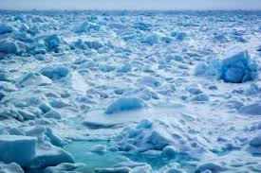 | 