Excerpts from Course Syllabus

Course Description
This course provides an introduction to experimental methods and designs used in social research for the health sciences. Students will design their own pilot studies and collect data through methods such as interviews, surveys, and observation. Analyzing their data, students will write research papers and give presentations to report their findings.

Course outcomes
Students will be able to:
- Understand and analyze texts intended for introductory academic audiences.
- Design and carry out a pilot study based on their knowledge of experimental methods and designs in social research.
- Analyze data from their own pilot study, and make meaningful statements about the data in writing and speaking.
- Write a research report, mostly using academic conventions appropriate for an American university audience, with guidance.
- Present research verbally, mostly using academic language appropriate for an American university audience, with guidance.
- Apply basic knowledge of source citation to research writing, demonstrated by citing paraphrases and quotations from social research data.

Assessment of Student Learning and Teaching Effectiveness
Students will be assessed based on their successful completion of the course requirements listed below.
Course Requirements
- Online Discussions (4) 20%
Students will participate in online discussions that will be posted to Blackboard. In these discussions, students should demonstrate critical analysis of the course topics as well as an ability to communicate with classmates regarding course concepts. It is expected that students will follow conventions of professional communication to the best of their ability when writing on Blackboard (proper grammar, spelling, capitalization, punctuation, etc.). Late submissions to the online discussions will not be graded.
- Quizzes (3) 15%
There will be quizzes throughout the semester to assess students’ understanding and application of course concepts and comprehension of assigned reading or listening assignments. These quizzes may include a variety of question types, such as multiple-choice, short answer, and fill-in-the-blank questions.
- Interview Project 10%
With a group, students will conduct an interview in English and record the interview. Students will then analyze their interview data and write a summary and analysis of the interview. Each student will submit a summary and analysis paper individually.
- Survey Project 10%
As a class, we will design and conduct a survey of the MCPHS University community. Students will analyze the results of the survey, and each student will create a chart or graph to display survey data and present this chart or graph to the class.
- Observation Project 15%
Students will work in groups to write a research proposal for a pilot observational study that relates to the health sciences. They will collect observer notes, analyze the notes for themes, and present an analysis of the notes to the class.
- Final Research Proposal Assignment 20%
Students will work in groups to create a written proposal to research a community health issue. Students’ proposed methodologies will include both qualitative and quantitative measures. They will cite data from outside sources and their own pilot studies to support their proposals. Students will present their research proposal to a panel of teachers and classmates in a mock “Institutional Review Board.”
- Participation 10%
Students will be expected to participate actively in the classroom. This means that students must do more than simply attend class. Students can show that they are actively participating in a variety of ways, including speaking during classroom discussions, doing daily readings and homework, asking questions, and remaining on-task during class. Students will receive one participation grade at midterm and one at the end of the semester.
Samples of Student Work
Interview Unit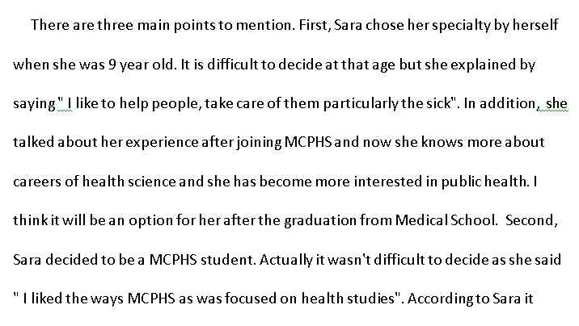
------------------------------------------------------------------------------------------------------------------


Survey Unit

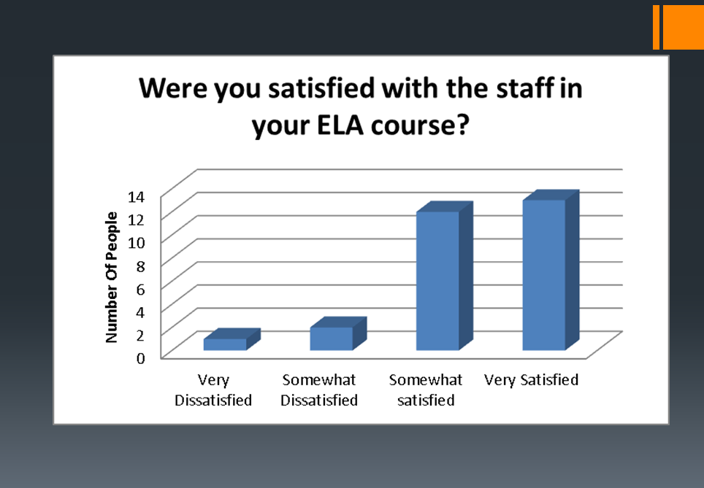

Observation Unit
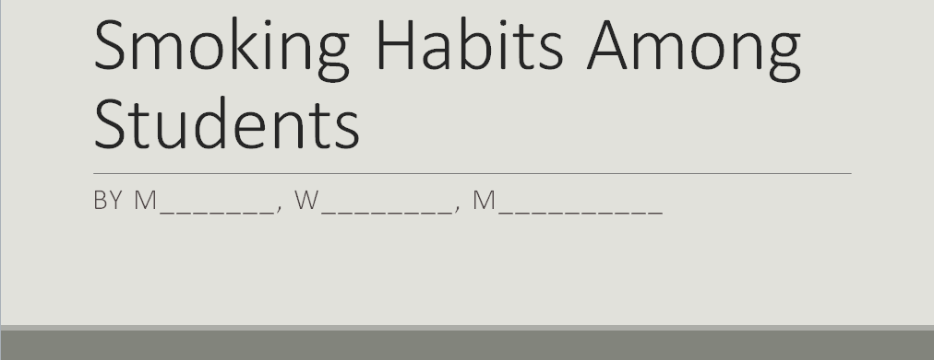
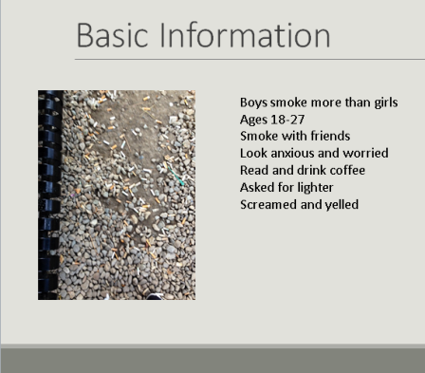
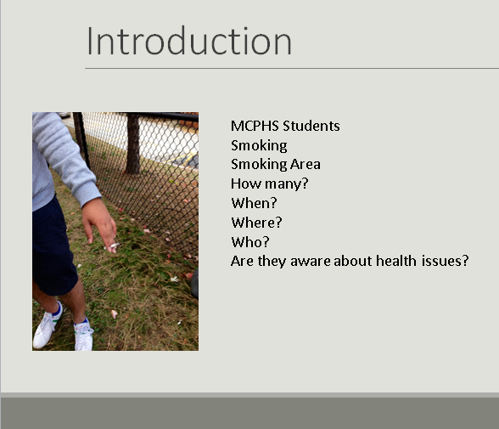
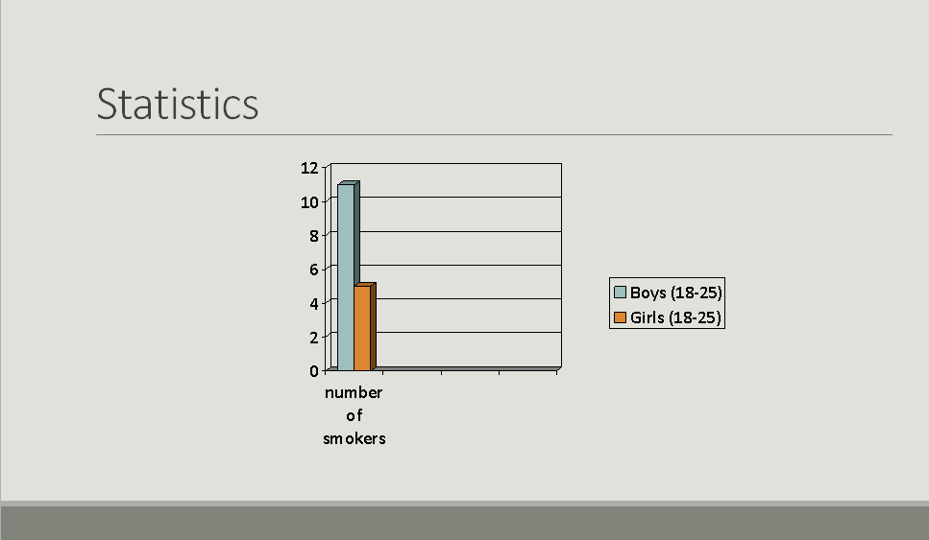

Research Proposal Unit



