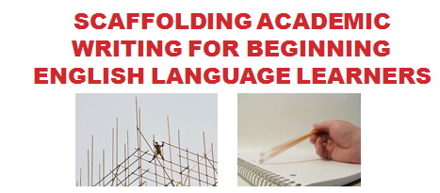

MATSOL
May 8, 2015

Allison Balter, UP Education Network, Boston/Lawrence
allison.e.balter@gmail.com

Lindsey Mayer, Garfield Middle School, Revere, MA
ljanemayer@gmail.com
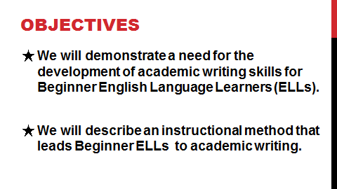

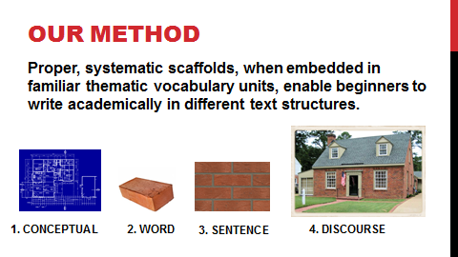

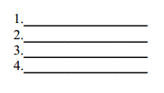
Use familiar pictures to build / connect to the concept of the text structure.
Sequence
SE
Sequence: Conceptual Level

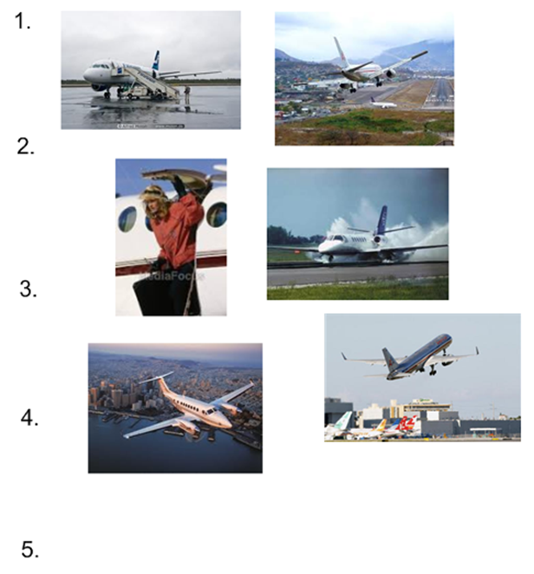

Other examples:
- Recipe
- Daily school schedule
- Daily routines

6.

lmayer@revere.mec.edu
Connect the pictures to the signal words of the given text structure.
- First, To begin, At the beginning
- Next, Then, After
- Last, Finally, In the end

Sequence
SE
Sequence: Word Level

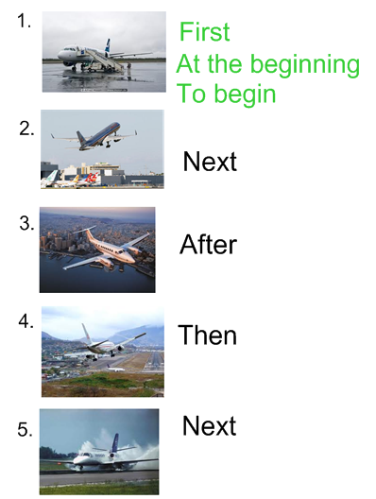
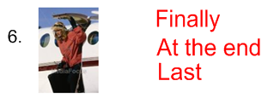

lmayer@revere.mec.edu
Embed the concept and signal words into the thematic unit students are studying. Students use their knowledge of the content and signal words to describe pictures.

Sequence
SE
Sequence: Sentence Level

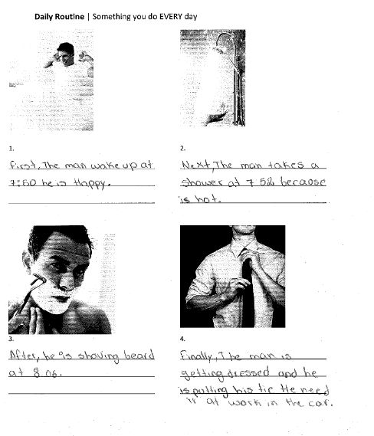

lmayer@revere.mec.edu
Students connect their previously written sentences to form an organized and structured paragraph. Modeling and co-constructing paragraphs first enables students to do this on their own.

Sequence
SE
Sequence: Discourse Level

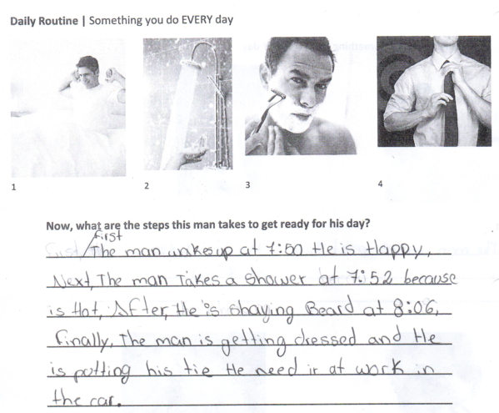

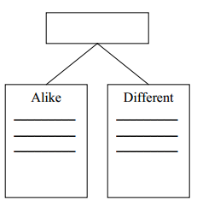
lmayer@revere.mec.edu
Introduce:
- idea of same and different and connect to terms compare / contrast
- concept through thematic vocabulary
- organizational structure

Compare & Contrast
Compare & Contrast: Conceptual Level

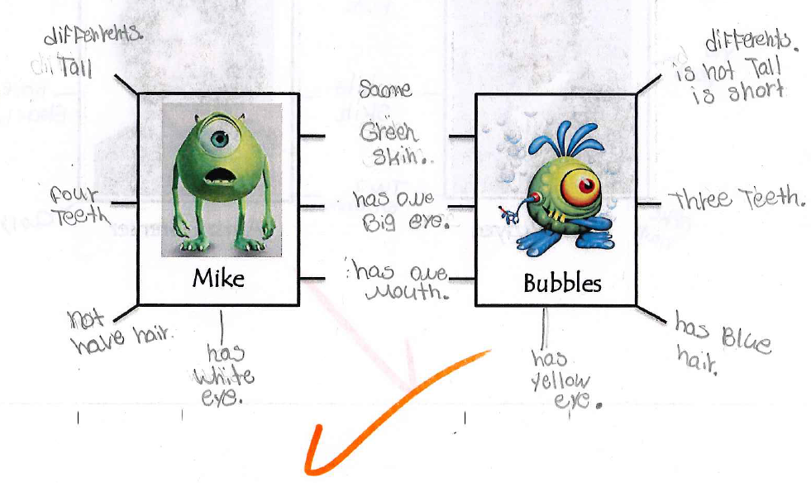

lmayer@revere.mec.edu
Use sentence frames to show students how they can combine their vocabulary with the signal words, using correct syntax, to form sentences that express their ideas.

Compare & Contrast
Compare & Contrast: Sentence Level

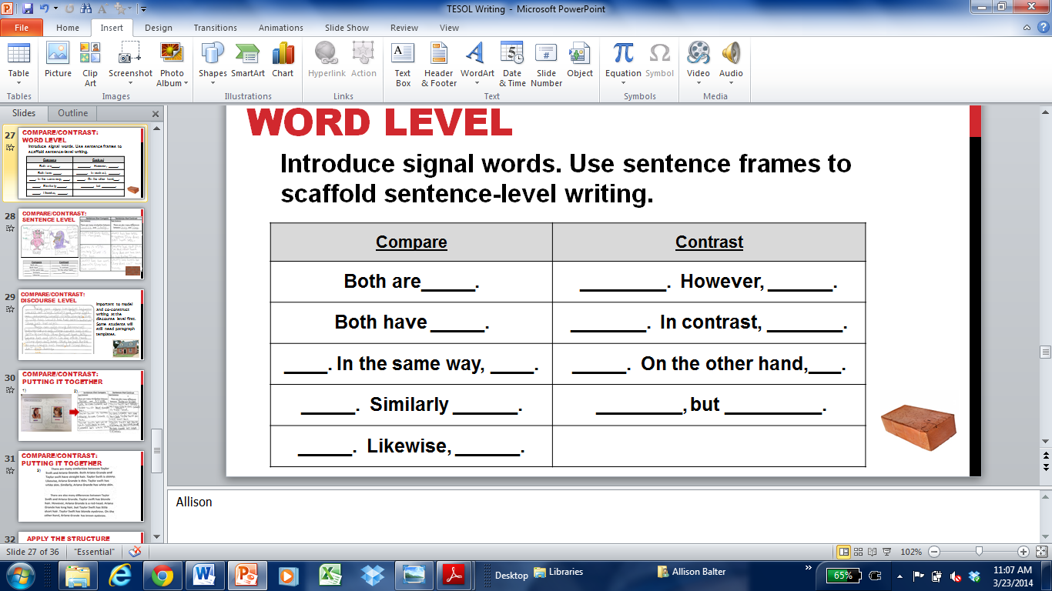

lmayer@revere.mec.edu
Model and co-construct writing at the discourse level first. Some students will still need paragraph templates.

Compare & Contrast
Compare & Contrast: Discourse Level

There are many similarities between _______ and _________. Both are ______________. _________ is __________. Similarly, __________ is _____________. __________ has _________. Likewise, ___________ has __________.
There are also many differences between ______ and ______. _______ has _______. In contrast, ________ does not have ______. _______ is _________. On the other hand, _______ is not _______. ________ has ________, but ________ does not have _________.
www.u-46.org/dbs/roadmap/files/comprehension/3expostext.pdf

